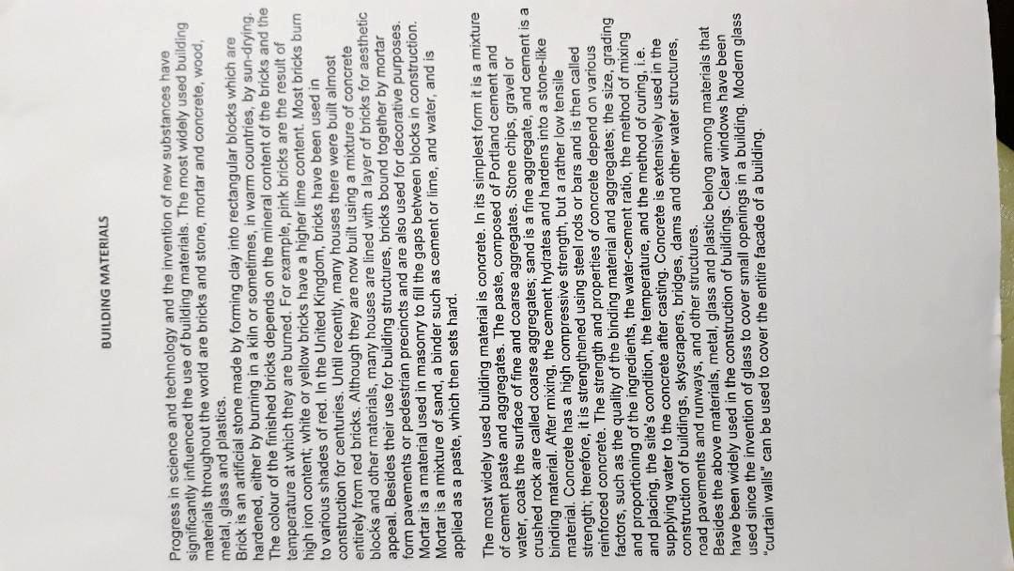

PRESENT SIMPLE OR PRESENT CONTINUOUS

1. Every Monday, Sally (drive) her kids to football practice.
2. Usually, I (work) as a secretary at ABT, but this summer I (study) French at a language school in Paris. That is why I am in Paris.
3. Shhhhh! Be quiet! John (sleep) .
4. Don't forget to take your umbrella. It (rain) .
5. I hate living in Seattle because it (rain, always) .
6. I'm sorry I can't hear what you (say) because everybody (talk) so loudly.
7. Justin (write, currently) a book about his adventures in Tibet. I hope he can find a good publisher when he is finished.
8. Jim: Do you want to come over for dinner tonight?
Denise: Oh, I'm sorry, I can't. I (go) to a movie tonight with some friends.
9. The business cards (be, normally ) printed by a company in New York. Their prices (be) inexpensive, yet the quality of their work is quite good.
10. This delicious chocolate (be) made by a small chocolatier in Zurich, Switzerland.

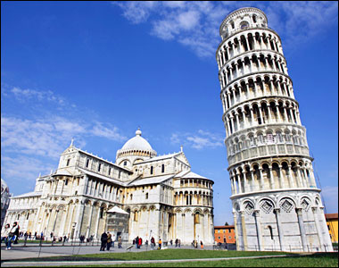
The Leaning Tower of Pisa is one of the most remarkable architectural structures in Europe. Most famous for its tilt, the tower began to lean during construction after soft ground on one side was unable to properly support the structure's weight.
Building work on the tower began in 1173 and went on for over 300 years.
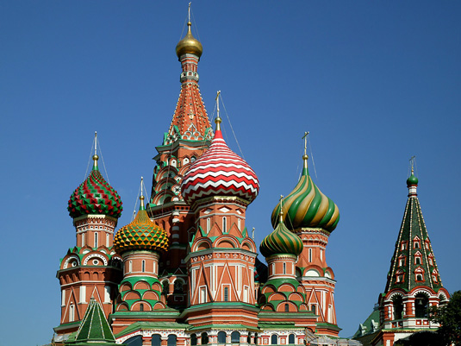
- This garish, candy colored cathedral is in fact Moscow's most visited tourist attraction. The famous landmark, shaped to resemble the flame of a bonfire rising into the sky, is located just outside the Kremlin gates and marks the geometric centre of the city.
- Built between 1554 and 1560, the cathedral was erected during the reign of Ivan IV (Ivan the Terrible).
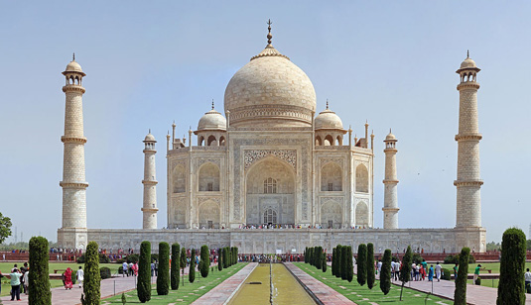

Recognized as 'the jewel of Muslim art in India', the Taj Mahal was built by Emperor Shah Jahan. Often mistaken as a palace, this famous landmark was actually built as a tomb for the Emperor's wife after she died giving birth to their 14th child.
Construction on the mausoleum began in 1632 and was completed in 1648. The surrounding buildings and gardens took a further five years to finish.

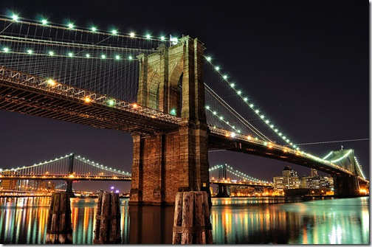
This is the oldest suspension bridge in the United States of America, having a total length of 1825 meters (5,989 feet). It is one of the most famous landmarks of New York City and 127 years after its opening it still serves its initial purpose: connecting Manhattan and Brooklyn. This bridge is also the first one in the world to use steel-wires for its suspension structure and in 1883, at its opening, was the longest bridge of its type on the planet.
In our days, the bridge carries three traffic lanes on each direction and a pedestrian/biker lane situated at an upper level.

